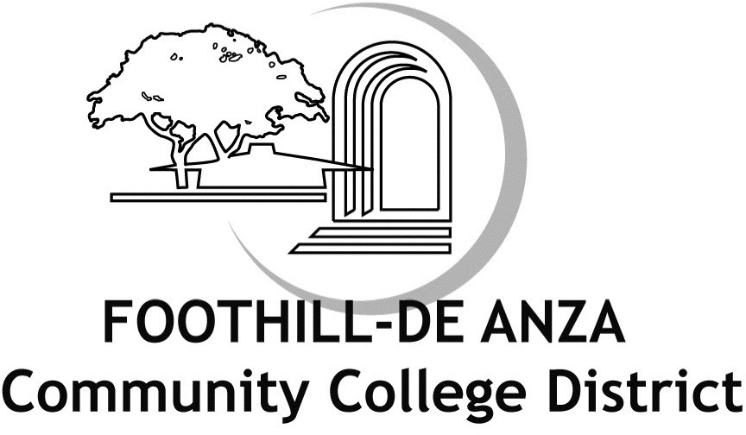

Book Administrative Procedures

Section Chapter 4 ­ Academic Affairs (including former Article 6 ­ Instruction and Curriculum) Title Graduation Requirements for Degrees and Certificates
Number AP 4100

Status New

Legal Title 5, Sections 55060 et seq.

Origin CCLC legally required ­ 11/28/18 APM ­ Revised to remove the number of units required for Cert of Achievement. Seeking senate feedback.

(CCLC NOTE: This procedure is legally required. Local practice may be inserted. Procedures must address at least the following:)

ASSOCIATE DEGREES

For the Associate in Arts or Associate in Science degree, a student must demonstrate competence in reading, in written expression, and in mathematics. The student must satisfactorily complete at least 90 quarter units of college work.

A definition of “college work” that provides that courses acceptable toward the associate degree include those that have been properly approved pursuant to Title 5 Section 55002(a), or, if completed at other than a California community college, would reasonably be expected to meet the standards of that section.

The work must include at least 27 quarter units in general education and at least 27 quarter units in a major listed in the Community Colleges “Taxonomy of Programs.”

The work must include at least 18 quarter units of study in residence; exceptions to the residence requirement can be made by the Board when an injustice or undue hardship would result.

The general education requirements must include a minimum of work in the natural sciences, the social and behavioral sciences, humanities, and language and rationality.

Students may petition to have noncredit courses counted toward the satisfaction of requirements for an associate degree. (Note: Verifying with CCLC that this is still required by Title 5.)

Ethnic studies must be offered.

District policies and procedures regarding general education and degree requirements must be published in the college catalog and must be filed with the California Community Colleges Chancellor’s Office.

CERTIFICATE PROGRAMS

For a certificate of achievement, a student must successfully complete a course of study or curriculum that meets or exceeds the legally required minimum number of units of degree­applicable credit coursework. The certificate of achievement shall

be designed to demonstrate that the student has completed coursework and developed capabilities relating to career or general education.

Shorter credit programs that lead to a certificate may be established by the District. (Note: With the change to the certificate of achievement language above, do we still need this statement?)

Content and assessment standards for certificates shall ensure that certificate programs are consistent with the mission of Foothill­De Anza Community College District, meet a demonstrated need, are feasible, and adhere to guidelines on academic achievement.

Certificates for which California Community Colleges Chancellor’s Office approval is not sought may be given any name or designation deemed appropriate except for certificate of achievement, certificate of completion, or certificate of competency.

See Board Policy 4100 Graduation Requirements for Degrees and Certificates

