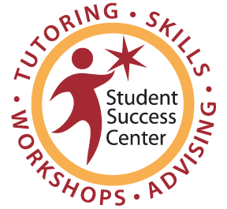
Math, Science & Technology Resource Center

Weekly Individual Tutoring (WIT)
Participant Agreement

Welcome to the Math, Science & Technology Resource Center (MSTRC)! We are pleased that you have taken the first steps to succeeding in your math class by taking advantage of our services offered this quarter. The Learning Resources Division and the Student Success Center are committed to your success in each of your classes!

Fully participating in the MSTRC services will provide you with the support and tools needed to succeed in your classes and academic goals. Our agreement to provide you with an individual tutor all quarter long is dependent upon you meeting the following expectations throughout the quarter.

All Weekly Individual Tutoring participants are responsible for the following:

__________ ATTENDANCE
(Initial) -I will maintain positive class attendance and participation.
-I will punctually attend all scheduled tutoring sessions.
-I understand that I will be dropped after two unexcused absences.

__________ PREPARATION
(Initial) -I will complete study skills readings and/or exercises prior to my sessions.
-I will take and bring class/lecture and textbook notes to my sessions.
-I will write down and ask my tutor questions I have for content and/or
study skills.

___________ COMMUNICATION
(Initial) -I will notify my tutor of any session cancellations and/or rescheduling with
at least a 24-hour notice. Exceptions may be made for emergencies.

___________ ASSIGNMENTS
(Initial) -I will work diligently to complete all assignments in a timely manner.
-I understand I may be dropped after two uncompleted skills exercises.

___________ CONDUCT
(Initial) -I will demonstrate a positive attitude & desire towards tutorial program.
-I will respect and follow MSTRC rules and guidelines. Especially in
maintaining my cell phone on silent and only utilizing it for emergencies.
-I will respect the faculty, staff, tutors, peers and myself while in the MSTRC.

___________ FIRST WEEKLY INDIVIDUAL TUTORING SESSION
(Initial) -I will complete the Pre-Skills Assessment prior to my first WIT session at:
Study Skills Assessment Link
-I understand that my first WIT session is dedicated to completing Study Skill #1 with my tutor, and if time is left over, we can work on course content.

I agree to abide by the guidelines set forth in this agreement.

__________________________________________ ____________________________________________ ______________
Print Name Signature Date

________________ _______________________________________ ______________________________________________
Course Instructor Tutor

